

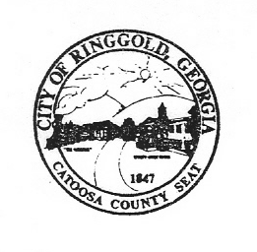

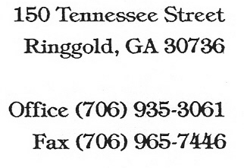

April 4, 2022

The Catoosa County News

P.O. Box 40

Ringgold, Georgia 30736

**Notification of Cancellation of Meeting**

CVB Regular Scheduled Meeting

April 5, 2022

The regular meeting for City of Ringgold Convention and Visitors Bureau Tuesday, April 5, 2022 at 5:30 p.m. at Ringgold City Hall, Ringgold, Georgia has been cancelled. The meeting will be rescheduled for a later date.

This 4th day of April 2022.

Ronal Graham

Chairman